**CSCE 336**

**Embedded Systems**

**Robot Design Project 1 Report**

## Wall Following

**Matthew Schlatter**

**School of Computing**

**University of Nebraska – Lincoln**

**Due Date: 4/2/24**

Table of Contents

**Title Page:** 1

Wall Following 1

**Objectives or Purpose:** 2

**Preliminary design:** 2

**Software flow chart or algorithms:** 3

**Hardware schematic:** 3

**Debugging:** 3

**Testing Methodology or Results:** 3

**Answers to Lab Questions:** 4

**Observations and Conclusions:** 4

**Documentation:** 4

# **Objectives or Purpose:**

This should include a paragraph on what is the goal of this assignment?

Remember, the purpose of the lab notebook is to communicate EVERYTHING you have done in pursuit of a particular project. If you are sitting on the bus scribbling on the back of an envelope about your lab design, take a picture of that and include it with your work. Without adequate documentation, your instructor won’t know what your thought process was and will not be able to grade you properly. Once you leave the school environment, fellow engineers may need to pick up your project where you left off if you move jobs, get hospitalized, or otherwise find yourself no longer working on something. You will save your employer/co-workers/replacement a lot of time and money if you have left a detailed record for them to easily understand what you were doing, the approach you took, the tests you performed, and what you learned.

This project is designed to have a robot follow a wall. Although this sounds like a simple task, it requires control of many different hardware aspects as well as good coding. To achieve this goal, multiple steps were taken. First, I had to learn how to use the ultrasonic sensor. This was done during lab 3, and

# **Preliminary design:**

How will you start attacking the problem? This should include detailed instructions of what you are about to do. It may include pre-lab material and also information from the Lab Handout. Use pictures and data from Lab Handout. You may also use snippets of code in here as well:

You should only include important key code snippets in your README. All code files should be included in code folder.

**Code:**

You should only include important key code snippets in your report with discussions of how you implemented functionalities. All code files should be included in code folder on Bitbucket.

Well-formatted code

All of your code should be written with:

1. headers
2. comments
3. good coding practices.

# **Software flow chart or algorithms:**

All coding include a pseudocode flow charts and algorithms defined your code and the algorithms used. Visio, PowerPoint, or Google Drawings works well for this!

Insert pseudocode or flowchart here.

# **Hardware schematic:**

The Fritzing diagram of the robot setup is shown below.

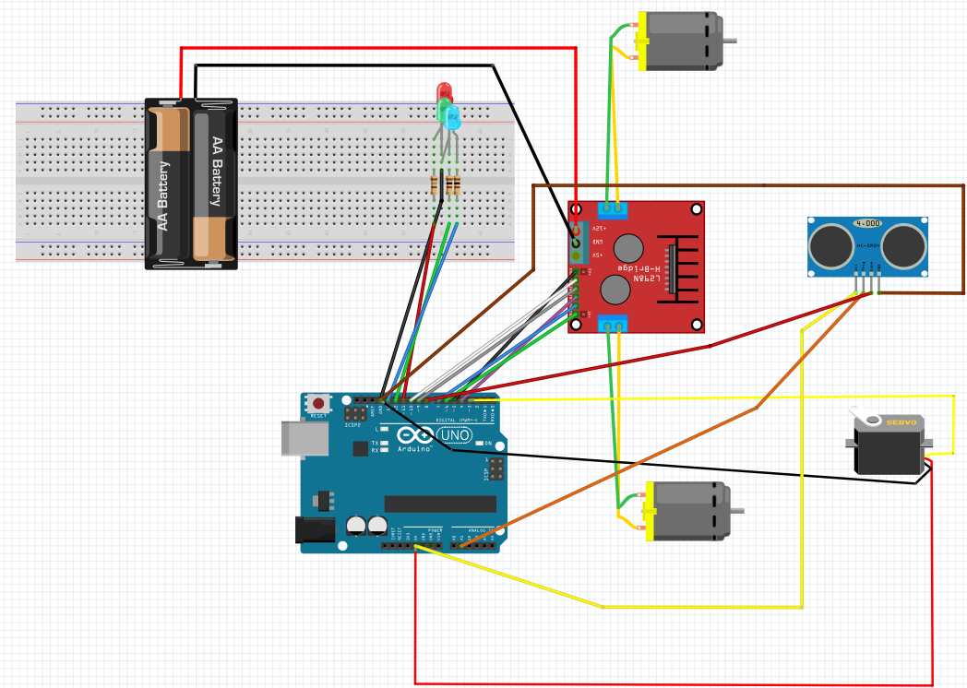

# **Debugging:**

You should be keeping track of issues as you go along. I didn't have any problems is not a good answer. Describe the problems you had and what you did to fix it. Again this is where I would say commit early and often and start your notebook when you start your code.

# **Testing Methodology or Results:**

Detail the steps in getting the results you system is designed to achieve. Have enough detail that someone can come behind and reproduce your results.

Display your results and describe them in detail so that anyone can understand. For example Figure 1 below shows a screenshot of a memory dump for RAM from 0x0200 to 0x024E. You will also describe to the reader what they are looking at.

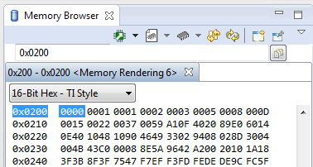

Figure 1: Memory Dump Label (Always include figure AND table labels!)

# **Answers to Lab Questions:**

Here is where you would answer any lab questions given in the lab writeup.

# **Observations and Conclusions:**

During this whole assignment, what did you learn? What did you notice that was noteworthy? This should be a paragraph starting with the purpose, whether or not you achieved that purpose, what you learned, and how you can use this for future labs.

# **Documentation:**

– You always include this! Document any help received on any portion of the assignment, even from an instructor, TA, or the internet should be specifically mentioned.